✅ MYFUTURE+ LESSON PLAN
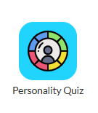
Understanding Yourself through the Personality Quiz
Section 1: Understanding and Developing Yourself
Duration: 45 Minutes
Programme: MyFuture+ /Personality Quiz app

🎯 Learning Outcomes
Students will:
- Understand personality traits and profiles.
- Identify their personal personality profile.
- Explore how personality links to jobs, apprenticeships and courses.
- Reflect on their learning from the Personality Profiler app.

🟢 Introduction (10 minutes)
Teacher Discussion:
Ask Students:
What is “Personality”?
Can personality change over time?
How might personality affect career choices?
Explain:
Personality describes how we think, feel and behave. Understanding personality helps guide career decisions and personal development. Our personality can be shaped over time through our experiences.
🟡 Activity 1 – Guess Your Personality Type (10 mins)
Students will:
- Predict their personality type before completing the profiler quiz.
- Take note of their initial thoughts.

🔵 Activity 2 – Complete Personality Profiler (20 mins)
Steps:
1. Open Personality Profiler app
2. Choose appropriate version
3. Answer all questions carefully
4. View your top type and read all the information provided. A PDF report can be printed for a portfolio or saved. Note if using the work experience app the result will be automatically integrated into the report.

🟣 Activity 3 – Career Exploration (10 mins)
Students match their personality results to the following:
- Sectors
- Jobs/Apprenticeships
- Explore suggested career and sector areas in the Career Explorer or Career Sector App (Section 2: Explore learning, life and work)

🔴 Reflection Activity (10 mins)
Students consider the following:
- Were you surprised by your results?
- Do the suggested careers suit you?
- What did you learn about yourself?
- How will this help you to plan your next step?
✅ Success Outcomes
Students can:
- Name and explain their personality profile.
- Match personality to some examples of careers
- Reflect on their learning including the strengths and limitations of their top personality type and consider this for future career planning.

📊 Assessment for Learning
- Teacher observation
- Completed worksheet
- Reflection responses in the relevant section in their app. This is viewable in the student portfolio.

🎯 Universal Design for Learning
Support:
Provide printed materials
Allow discussion before writing
Extension:
Research a career linked to personality
Explore another MyFuture+ app

📚 Resources Needed
Devices with internet
Personality Profiler access
Reflection worksheet


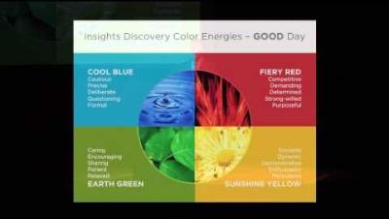
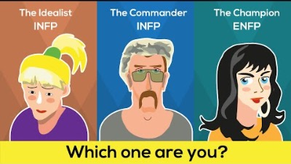
📚 Additional Resources (Videos – in PowerPoint Presentation)
15-minute video. Personality and the brain Ted Talk.
13-minute video. How rare is your personality type video?
11-minute video. The concept of personality

